LegalWise Installation Guide

1. Create a BlueMix account. URL: <https://console.ng.bluemix.net/registration/>

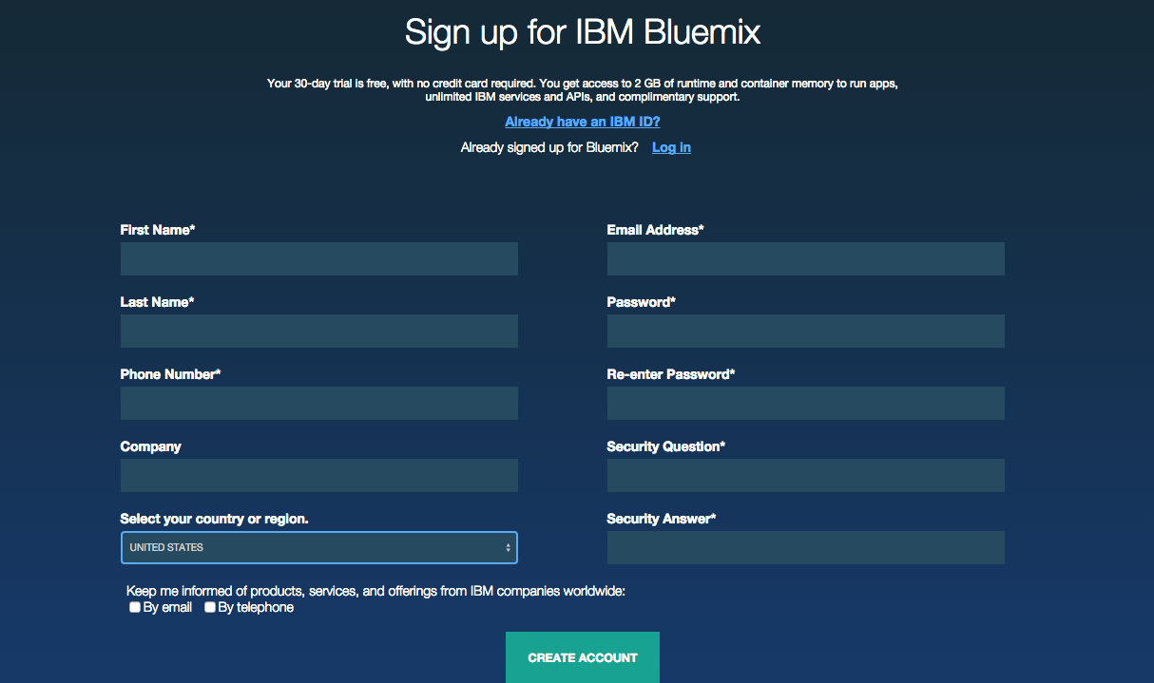

1. Install Node.JS URL: <https://nodejs.org/en/download/>
2. Download the project. (Install Git if you do not have it)
3. Log into your BlueMix account. (I will use my own account for reference)
4. Navigate to dashboard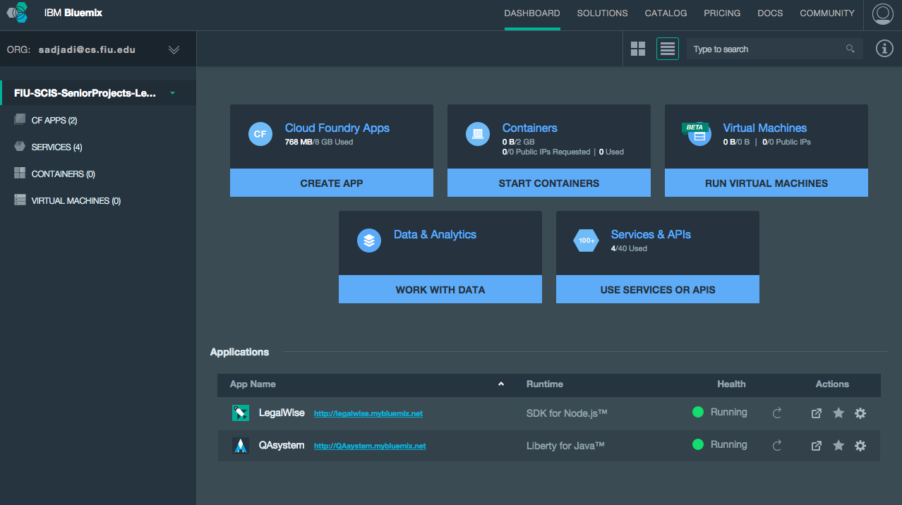
5. Click on the LegalWise project.
6. Copy the Git url

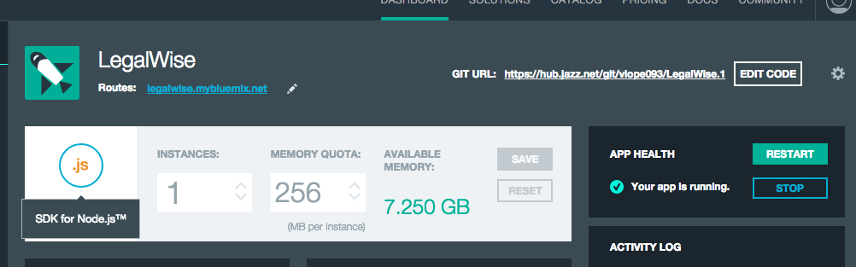

1. Open command line and go to the directory that you want to locate the project.
2. Clone the project from Git by typing this command - git clone <git-url>

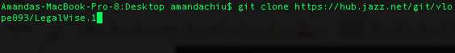

1. Run the application on localhost:
2. Install all the modules and dependencies by typing this command – npm install
3. Run the application by typing this command – node app.js
4. As you can see the server is running on localhost with a port number, copy that URL, and open it with a browser. (Chrome / Safari)

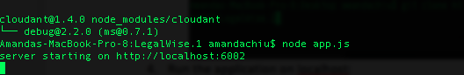

1. You should be able to see the homepage like the screenshot below: 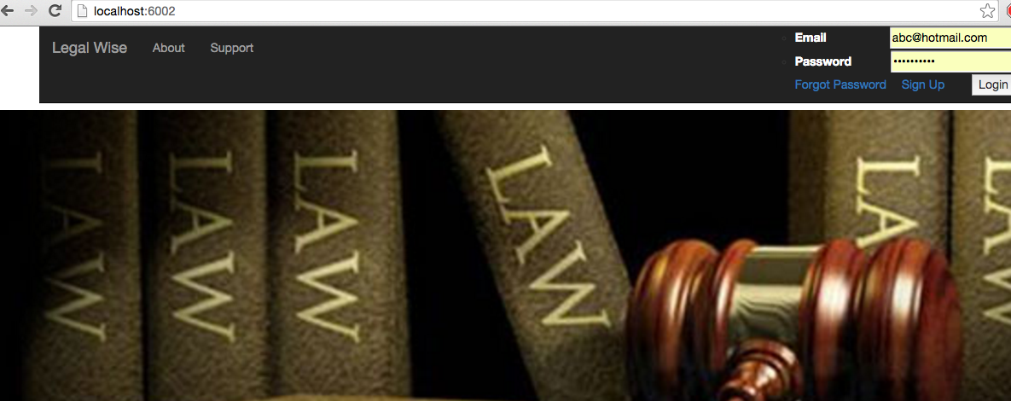
2. Run the application on BlueMix:
3. Simply go back to your BlueMix account, go to dashboard and click on the link - <http://legalwise.mybluemix.net/>
4. Access the database:
   1. This project uses the Cloudant NoSQL database, to access it, simply go to BlueMix LegalWise dashboard, and click on Cloudant NoSQL database.

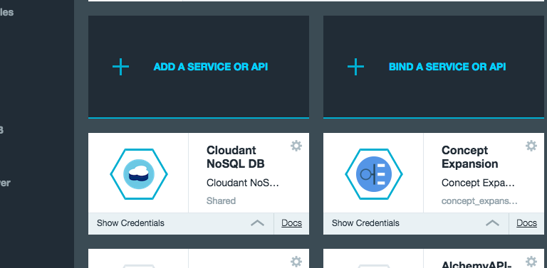

* 1. Then click Launch on the right hand side.
  2. You should be able to see the legalwise database: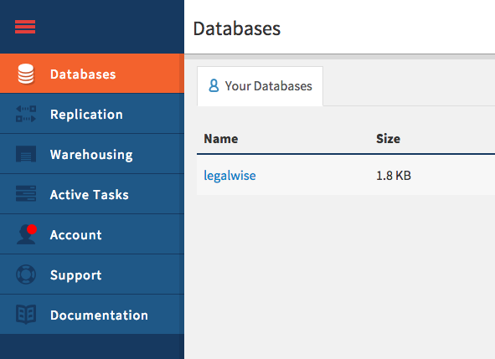
  3. You can edit and save user’s information here:

